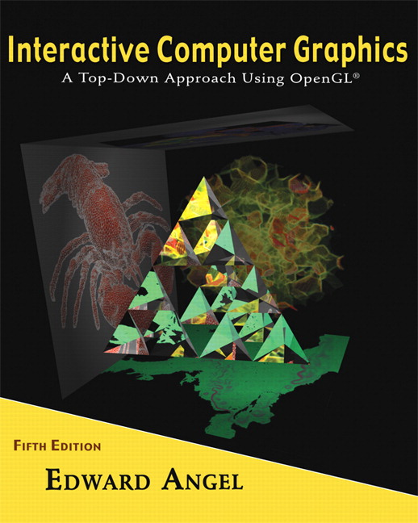

Name: ______________________ Terminal # ____
Programming Assignment 2
(100 points)

The Programming Assignment is to be turned in the first ten minutes of the due date class as:

Hardcopy (with your terminal #!)
Source Code and Screenshots that shows that your Visual Studio 2010 “Programming Assignment 2” PROJECT compiles and runs!

Electronic: Submit the Visual Studio2010 “Programming Assignment 2” zipped PROJECT to BB so you can run it in 200 PGH!

S’COOL BUS - Summer 2012 Modeling Instructions
(The file “S’COOL BUS Summer 2012.pdf” contains the specifications for the BUS that you started modeling.)

1. The glutCreateWindow OpenGL call will take as parameter “YourLastName BUS Version 2”.
2. Start with the BUS.c that you have created in Programming Assignment 1 and call the file MyBUS.c. Please make sure that the colors schema is observed.

3. Create a menu or keyboard (f, b, r, l, t, u, i) that allows that you to view the BUS from (F1 is the Help Key):

- front;
- back;
- right side;
- left side;
- top;
- under;
- isometric.

Get a screenshot of the “YourLastName BUS Version 2” window for each view.

4. Add the fly through navigation to the BUS from (see Homework 3).

